 | CÔNG TY CP BẢO TRÌ KỸ THUẬT CÔNG NGHIỆP  Trụ sở: Lầu 1, số 788/51C Nguyễn Kiệm, P.3, Q.Gò Vấp, TP.HCM  Tel: 0866749689, 0913771002, Fax: 0837261650  Web site : http://www.vanduongong.com, lengoc_vinh@yahoo.com  Emai:baotri.kythuat@gmail.com, info@vanduongong.com

Sản Phẩm |  |  | Thông số kỹ thuật
Model | Hình ảnh |  | Power  (∮/V/Hz) | I  (A) | P  (W) | Q  (m3/h) | Áp lực  (mmAq) | T. độ  (Rpm) | T. ồn  (dB) | m  (Kg)
Quạt thổi khí áp suất cao đa cấp (Hight-pressure multilevel blowers)
ITB-S411S | 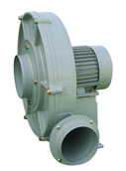 |  | 1/220/60 | 7.5 | 1,750 | 1,620 | 300 | 3,400 | 80 | 24
 |  |  | 1/220/50 | 5.3 | 1,100 | 1,380 | 226 | 2,900
ITB-S411T |  |  | 3/220-380/60 | 5.3/2.9 | 1,750 | 1,620 | 300 | 3,370 | 80 | 24
 |  |  | 3/220-380/50 | 4.1/2.3 | 1,100 | 1,380 | 226 | 2,900
ITB-411S | 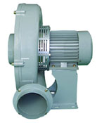 |  | 1/220/60 | 7.5 | 1,750 | 1,620 | 300 | 3,400 | 80 | 23
 |  |  | 1/220/50 | 5.3 | 1,100 | 1,380 | 226 | 2,900
ITB-411T |  |  | 3/220-380/60 | 5.3/2.9 | 1,750 | 1,620 | 300 | 3,370 | 80 | 23
 |  |  | 3/220-380/50 | 4.1/2.3 | 1,100 | 1,380 | 226 | 2,900
ITB-412T | 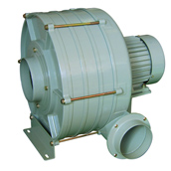 |  | 3/220-380/60 | 6.4/3.6 | 2,050 | 1,200 | 555 | 3,400 | 82 | 32
 |  |  | 3/220-380/50 | 5.6/3.3 | 1,330 | 1,020 | 405 | 2,900
ITB-413T |  |  | 3/220-380/60 | 8.2/5.0 | 2,650 | 1,200 | 725 | 3,459 | 85 | 38
 |  |  | 3/220-380/50 | 8.2/4.5 | 1,780 | 1,020 | 510 | 2,940
ITB-414T |  |  | 3/220-380/60 | 11/6.08 | 3,300 | 1,200 | 1,100 | 3,485 | 86 | 42
 |  |  | 3/220-380/50 | 9.0/5.0 | 2,200 | 1,020 | 775 | 2,920
ITB-S412T | 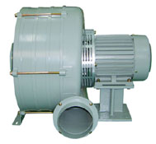 |  | 3/220-380/60 | 6.4/3.6 | 2,050 | 1,200 | 555 | 3,400 | 82 | 33
 |  |  | 3/220-380/50 | 5.6/3.3 | 1,330 | 1,020 | 405 | 2,900
ITB-S413T |  |  | 3/220-380/60 | 8.2/5.0 | 2,650 | 1,200 | 725 | 3,459 | 85 | 39
 |  |  | 3/220-380/50 | 8.2/4.5 | 1,780 | 1,020 | 510 | 2,094
ITB-S414T |  |  | 3/220-380/60 | 11/6.08 | 3,300 | 1,200 | 1,100 | 3,485 | 86 | 43
 |  |  | 3/220-380/50 | 9.0/5.0 | 2,200 | 1,020 | 775 | 2,920
ITB-401S |  |  | 1/220/60 | 4.95 | 1,080 | 600 | 352 | 3,435 | 83 | 20.5
 | 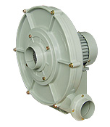 |  | 1/220/50 | 3.6 | 725 | 510 | 260 | 2,925
ITB-401T |  |  | 3/220-380/60 | 3.3/1.9 | 1,180 | 600 | 352 | 3,390 | 83 | 20.5
 |  |  | 3/220-380/50 | 2.1/1.4 | 735 | 510 | 260 | 2,920
ITB-402S |  |  | 1/220/60 | 6.9 | 1,525 | 630 | 635 | 3,480 | 83 | 25.5
 |  |  | 1/220/50 | 5.85 | 1,330 | 540 | 465 | 2,938
ITB-402T |  |  | 3/220-380/60 | 4.7/2.65 | 1,610 | 630 | 635 | 3,450 | 83 | 25.5
 |  |  | 3/220-380/50 | 3.25/1.9 | 900 | 540 | 465 | 2,942
ITB-S401S |  |  | 1/220/60 | 4.95 | 1,080 | 600 | 352 | 3,435 | 83 | 21.5
 | 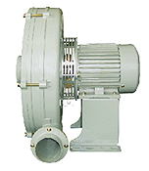 |  | 1/220/50 | 3.6 | 725 | 510 | 260 | 2,925
ITB-S401T |  |  | 3/220-380/60 | 3.3/1.9 | 1,180 | 600 | 352 | 3,390 | 83 | 21.5
 |  |  | 3/220-380/50 | 2.1/1.4 | 735 | 510 | 260 | 2,920
ITB-S402S |  |  | 1/220/60 | 6.9 | 1,525 | 630 | 635 | 3,480 | 83 | 26.5
 |  |  | 1/220/50 | 5.85 | 1,330 | 540 | 465 | 2,938
ITB-S402T |  |  | 3/220-380/60 | 4.7/2.65 | 1,610 | 630 | 635 | 3,450 | 83 | 26.5
 |  |  | 3/220-380/50 | 3.25/1.9 | 900 | 540 | 465 | 2,942
Sò cao áp (Turbo blowers)
TBS-3235S | 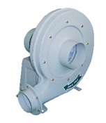 |  | 1/220/60 | 4.7 | 1,300 | 1,560 | 265 | 3,410 | 83 | 35
 |  |  | 1/220/50 | 3.8 | 900 | 1,365 | 196 | 2,850
TBS-3235T |  |  | 3/220-380/60 | 3.1/1.8 | 1,300 | 1,560 | 265 | 3,410 | 83 | 35
 |  |  | 3/220-380/50 | 2.6/1.5 | 856 | 1,365 | 196 | 2,850 | 2850
 |  |  | 1HP
TBS-S3235S | 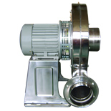 |  | 1/220/60 | 4.7 | 1,300 | 1,560 | 265 | 3,410 | 83 | 35.5
 |  |  | 1/220/50 | 3.8 | 900 | 1,365 | 196 | 2,850 | 2850
TBS-S3235T |  |  | 3/220-380/60 | 3.1/1.8 | 1,300 | 1,560 | 265 | 3,410 | 83 | 35.5
 |  |  | 3/220-380/50 | 2.6/1.5 | 856 | 1,365 | 196 | 2,850 | 2850
 |  |  | 1HP
TBS-3245S |  |  | 1/220/60 | 7 | 1,800 | 2,400 | 285 | 3,460 | 87 | 40
 |  |  | 1/220/50 | 5.7 | 1,540 | 2,100 | 210 | 2,920 | 2850
TBS-3245T |  |  | 3/220-380/60 | 4.5/2.6 | 1,800 | 2,400 | 285 | 3,460 | 87 | 40
 |  |  | 3/220-380/50 | 3.7/2.2 | 1,540 | 2,100 | 210 | 2,920 | 2850
 |  |  | 2HP
TBS-S3245S |  |  | 1/220/60 | 7 | 1,800 | 2,400 | 285 | 3,460 | 87 | 40
 |  |  | 1/220/50 | 5.7 | 1,540 | 2,100 | 210 | 2,920 | 2850
TBS-S3245S |  |  | 3/220-380/60 | 4.5/2.6 | 1,800 | 2,400 | 285 | 3,460 | 87 | 40
 |  |  | 3/220-380/50 | 3.7/2.2 | 1,540 | 2,100 | 210 | 2,920 | 2850
 |  |  | 2HP
TBS-3735S  (3HP) |  |  | 1/220/60 | 8.2 | 2,800 | 3,120 | 320 | 3,450 | 90 | 45
 |  |  | 1/220/50 | 7 | 2,300 | 2,730 | 237 | 2,915
TBS-3735T  (3HP) |  |  | 3/220-380/60 | 5.3/3.1 | 2,800 | 3,120 | 320 | 3,450 | 90 | 45
 |  |  | 3/220-380/50 | 4.5/2.6 | 2,300 | 2,730 | 237 | 2,915
TBS-3765T  (5HP) |  |  | 3/220-380/60 | 13/7.7 | 4,200 | 4,020 | 380 | 3,460 | 92 | 50
 |  |  | 3/220-380/50 | 11/6.3 | 3,400 | 3,510 | 280 | 2,980
TBS-S3735S  (3HP) |  |  | 1/220/60 | 8.2 | 2,800 | 3,120 | 320 | 3,450 | 90 | 46
 |  |  | 1/220/50 | 7 | 2,300 | 2,730 | 237 | 2,915
TBS-S3735T  (3HP) |  |  | 3/220-380/60 | 5.3/3.1 | 2,800 | 3,120 | 320 | 3,450 | 90 | 46
 |  |  | 3/220-380/50 | 4.5/2.6 | 2,300 | 2,730 | 237 | 2,915
TBS-S3765T  (5HP) |  |  | 3/220-380/60 | 13/7.7 | 4,200 | 4,020 | 380 | 3,460 | 92 | 51
 |  |  | 3/220-380/50 | 11/6.3 | 3,400 | 3,510 | 280 | 2,980
Cabinet fans-Double inlet & blower for dust collectors
ITC-230GS |  |  | 1/220/60 | 1.3 | 320 | 1,800 | 24 | 1,160 | 61 | 26
 | 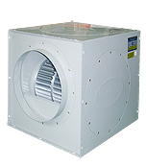 |  | 1/220/50 | 1.2 | 190 | 1,440 | 16 | 960
ITC-230GT |  |  | 3/220-380/60 | 1.0/0.6 | 240 | 1,800 | 24 | 1,150 | 61 | 26
 |  |  | 3/220-380/50 | 0.6/0.36 | 170 | 1,440 | 16 | 950
ITC-250GS |  |  | 1/220/60 | 2.8 | 570 | 2,900 | 35 | 1,100 | 63 | 33
 |  |  | 1/220/50 | 1.68 | 340 | 2,320 | 24 | 940
ITC-250GT |  |  | 3/220-380/60 | 2.6/1.6 | 560 | 2,900 | 35 | 1,120 | 63 | 33
 |  |  | 3/220-380/50 | 1.56/0.96 | 390 | 2,320 | 24 | 945
ITC-300GS |  |  | 1/220/60 | 5.9 | 1,190 | 4,500 | 50 | 1,120 | 68 | 51
 |  |  | 1/220/50 | 4 | 710 | 3,800 | 37 | 960
ITC-300GT | 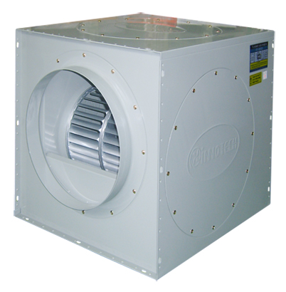 |  | 3/220-380/60 | 5.7.0/3.4 | 1,140 | 4,500 | 50 | 1,145 | 68 | 51
 |  |  | 3/220-380/50 | 3.8/2.3 | 680 | 3,800 | 37 | 970
ITC-380HS |  |  | 1/220/60 | 7.5 | 1,500 | 8,500 | 54 | 810 | 70 | 66
 |  |  | 1/220/50 | 5.2 | 910 | 7,100 | 46 | 710
ITC-380HT |  |  | 3/220-380/60 | 7.3/3.1 | 1,450 | 8,500 | 54 | 815 | 70 | 66
 |  |  | 3/220-380/50 | 5.1/2.2 | 870 | 7,100 | 46 | 720
ITC-400GT |  |  | 3/220-380/60 | 16.5/9.9 | 3,500 | 12,000 | 88 | 1,100 | 75 | 66
 |  |  | 3/220-380/50 | 11.5/6.8 | 2,100 | 10,200 | 73 | 950
Sò nhỏ (Small sirocco blowers)
TIS-140FS | 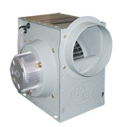 |  | 1/220/60 | 0.3 | 60 | 510 | 12 | 1,365 | 42 | 4.5
 |  |  | 1/220/50 | 0.2 | 48 | 443 | 9 | 1,335 | 53
TIS-160FS |  |  | 1/220/60 | 0.6 | 131 | 900 | 20 | 1,350 | 53 | 7
 |  |  | 1/220/50 | 0.5 | 105 | 783 | 16 | 1,335
TIS-190FS | 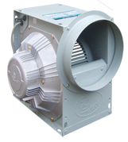 |  | 1/220/60 | 1.6 | 360 | 1,260 | 31 | 1,530 | 56 | 10.5
 |  |  | 1/220/50 | 1.3 | 288 | 1,090 | 24 | 1,410
TIS-190FT |  |  | 3/220-380/60 | 2.1/1.2 | 360 | 1,260 | 31 | 1,510 | 56 | 10.5
 |  |  | 3/220-380/50 | 0.9/0.7 | 278 | 1,090 | 24 | 1,395
TIS-250GS  (Ø250 x 130) |  |  | 1/220/60 | 2.1 | 428 | 2,520 | 25 | 1,130 | 60 | 20.3
 |  |  | 1/220/50 | 1.9 | 342 | 2,190 | 19 | 985
TIS-250GT  (Ø250 x 130) |  |  | 3/220-380/60 | 2.1/1.4 | 428 | 2,520 | 25 | 1,150 | 60 | 20.3
 |  |  | 3/220-380/50 | 2.3/1.4 | 328 | 2,190 | 19 | 990
TIS-280FS  (Ø250 x 130) |  |  | 1/220/60 | 5.8 | 1,280 | 3,600 | 45 | 1,725 | 64 | 22.3
 |  |  | 1/220/50 | 5.2 | 935 | 3,060 | 35 | 1,460
TIS-280FT  (Ø250 x 130) | 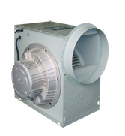 |  | 3/220-380/60 | 4.1/2.4 | 1,280 | 3,600 | 45 | 1,710 | 64 | 22.3
 |  |  | 3/220-380/50 | 2.9/1.7 | 890 | 3,060 | 35 | 1,455
TIS-280GS  (Ø250 x 150) |  |  | 1/220/60 | 2.3 | 514 | 3,240 | 27 | 1,125 | 62 | 22.3
 |  |  | 1/220/50 | 2.1 | 412 | 2,820 | 21 | 980
TIS-280GT  (Ø250 x 150) |  |  | 3/220-380/60 | 2.2/1.3 | 514 | 3,240 | 27 | 1,150 | 62 | 22.3
 |  |  | 3/220-380/50 | 2.4/1.3 | 398 | 2,820 | 21 | 985
TIS-290FS  (Ø250 x 150) |  |  | 1/220/60 | 6.8 | 1,420 | 4,680 | 53 | 1,690 | 72 | 25
 |  |  | 1/220/50 | 5.9 | 1,190 | 3,970 | 41 | 1,450
TIS-290FT  (Ø250 x 150) |  |  | 3/220-380/60 | 4.7/2.8 | 1,420 | 4,680 | 53 | 1,710 | 72 | 25
 |  |  | 3/220-380/50 | 4.9/2.7 | 1,205 | 3,970 | 41 | 1,460
TIS-290GS  (Ø250 x 150) |  |  | 1/220/60 | 2.4 | 530 | 3,300 | 23 | 1,145 | 63 | 25
 |  |  | 1/220/50 | 2.2 | 424 | 2,870 | 18 | 985
TIS-S250GS |  |  | 1/220/60 | 2.1 | 428 | 2,520 | 25 | 1,130 | 60 | 20.3
 | 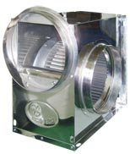 |  | 1/220/50 | 1.9 | 342 | 2,190 | 19 | 985
TIS-S250GT |  |  | 3/220-380/60 | 2.1/1.4 | 428 | 2,520 | 25 | 1,150 | 60 | 20.3
 |  |  | 3/220-380/50 | 2.3/1.4 | 328 | 2,190 | 19 | 990
TIS-S280FS |  |  | 1/220/60 | 5.8 | 1,280 | 3,600 | 45 | 1,725 | 64 | 22.3
 |  |  | 1/220/50 | 5.2 | 935 | 3,060 | 35 | 1,460
TIS-S280FT |  |  | 3/220-380/60 | 4.1/2.4 | 1,280 | 3,600 | 45 | 1,710 | 64 | 22.3
 |  |  | 3/220-380/50 | 2.9/1.7 | 890 | 3,060 | 35 | 1,455
Sò lồng sóc lớn (Large sirocco blowers)
TIS-310GS |  |  | 1/220/60 | 5.9 | 1,200 | 5,670 | 21 | 1,130 | 65 | 51
 | 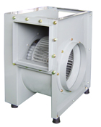 |  | 1/220/50 | 4.9 | 890 | 4,875 | 16 | 950
TIS-310GT |  |  | 3/220-380/60 | 4.1/2.4 | 1,200 | 5,670 | 21 | 1,135 | 65 | 51
 |  |  | 3/220-380/50 | 3.3/1.8 | 830 | 4,875 | 16 | 955
TIS-370GS |  |  | 1/220/60 | 11.4 | 2,400 | 8,580 | 40 | 1,115 | 67 | 54
 |  |  | 1/220/50 | 8.7 | 1,790 | 7,200 | 30 | 965
TIS-370GT |  |  | 3/220-380/60 | 9.2/5.8 | 2,400 | 8,580 | 40 | 1,110 | 67 | 54
 |  |  | 3/220-380/50 | 7.1/3.7 | 1,690 | 7,200 | 30 | 960
TIS-B310FS | 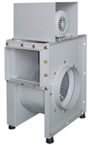 |  | 1/220/60 | 8.2 | 1,800 | 7,000 | 35 | 1,690 | 66 | 52
 |  |  | 1/220/50 | 7.6 | 1,335 | 5,985 | 27 | 1,450
TIS-B310FT |  |  | 3/220-380/440/60 | 6.1/3.6 | 1,830 | 7,000 | 35 | 1,710 | 66 | 52
 |  |  | 3/220-380/440/50 | 4.3/2.6 | 1,305 | 5,985 | 27 | 1,460
 |  |  | Kích thước cánh quạt (mm): Ø310 x 165
TIS-390GT | 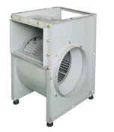 |  | 3/220-380/60 | 9.5/7.5 | 3,500 | 11,800 | 42 | 1,150 | 69 | 68
 |  |  | 3/220-380/50 | 8.7/4.9 | 2,270 | 9,900 | 31 | 980
TIS-390HT |  |  | 3/220-380/60 | 5.1/2.9 | 1,700 | 7,800 | 22 | 880 | 65 | 68
 |  |  | 3/220-380/50 | 4.3/2.6 | 1,428 | 6,550 | 17 | 755
 |  |  | Kích thước cánh quạt (mm): Ø390 x 170
Quạt hướng trục thân tròn (Portable fans)
TIP-200S  (Ø170 mm) |  |  | 1/220/60 | 0.8 | 190 | 1,140 | 30 | 3,280 | 61 | 6.5
 | 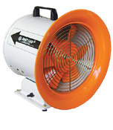 |  | 1/220/50 | 0.7 | 140 | 1,250 | 23 | 2,840
TIP-250S  (Ø220 mm) |  |  | 1/220/60 | 1.3 | 310 | 3,060 | 38 | 3,410 | 65 | 7.6
 |  |  | 1/220/50 | 1.1 | 230 | 2,660 | 29 | 2,950
TIP-300S  (Ø270 mm) |  |  | 1/220/60 | 1.9 | 440 | 3,780 | 50 | 3,300 | 67 | 11
 |  |  | 1/220/50 | 1.5 | 325 | 3,280 | 38 | 2,850
TIP-350S  (Ø320 mm) |  |  | 1/220/60 | 4.1 | 890 | 6,900 | 80 | 3,420 | 70 | 18
 |  |  | 1/220/50 | 3.1 | 658 | 6,010 | 60 | 2,960
TIP-250S-1 | 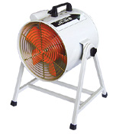 |  | 1/220/60 | 1.3 | 310 | 3,060 | 38 | 3,410 | 65 | 7.6
 |  |  | 1/220/50 | 1.1 | 230 | 2,660 | 29 | 2,950
TIP-300S-1 |  |  | 1/220/60 | 1.9 | 440 | 3,780 | 50 | 3,300 | 67 | 11
 |  |  | 1/220/50 | 1.5 | 325 | 3,280 | 38 | 2,850
 |  |  | Kích thước cánh quạt (mm): TIP-250S-1 (Ø220 mm); TIP-300S-1 (Ø270 mm)
TIP-400S | 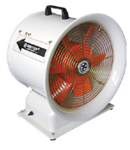 |  | 1/220/60 | 0.8 | 400 | 6,060 | 30 | 1,620 | 66 | 22.8
 |  |  | 1/220/50 | 0.7 | 280 | 5,272 | 23 | 1,415
TIP-500S |  |  | 1/220/60 | 4.8 | 990 | 10,560 | 39 | 1,680 | 69 | 31.2
 |  |  | 1/220/50 | 3.3 | 690 | 8,970 | 29 | 1,465
 |  |  | Kích thước cánh quạt (mm): TIP-400S (Ø370 mm); TIP-500S (Ø470 mm)
TIP-400S-1  (Ø370 mm) |  |  | 1/220/60 | 1.9 | 400 | 6,060 | 30 | 1,620 | 66 | 24.2
 | 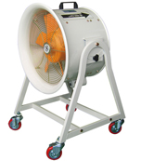 |  | 1/220/50 | 1.4 | 280 | 5,272 | 23 | 1,415
TIP-400T-1  (Ø370 mm) |  |  | 3/220-380/60 | 1.5/0.9 | 400 | 6,060 | 30 | 1,650 | 66 | 24.2
 |  |  | 3/220-380/50 | 1.6/1.0 | 280 | 5,272 | 23 | 1,435
TIP-500S-1  (Ø470 mm) |  |  | 1/220/60 | 4.8 | 990 | 10,560 | 39 | 1,680 | 69 | 34.6
 |  |  | 1/220/50 | 3.3 | 690 | 8,970 | 29 | 1,465
TIP-500T-1  (Ø470 mm) |  |  | 3/220-380/60 | 6.2/3.3 | 990 | 10,560 | 39 | 1,690 | 69 | 34.6
 |  |  | 3/220-380/50 | 3.6/2.2 | 690 | 8,970 | 29 | 1,455
TIP-600S-1 | 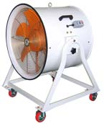 |  | 1/220/60 | 6.4 | 1,400 | 25,200 | 60 | 1,620 | 88 | 57
 |  |  | 1/220/50 | 3.8 | 850 | 21,000 | 43 | 1,415
TIP-600T-1 |  |  | 3/220-380/60 | 6.2/3.3 | 1,260 | 25,200 | 60 | 1,650 | 88 | 57
 |  |  | 3/220-380/50 | 3.6/2.2 | 850 | 21,300 | 43 | 1,415
 |  |  | Kích thước cánh quạt (mm): Ø600 mm
TIP-400D  (Ø370 mm) |  |  | 1/220/60 | 1.9 | 400 | 6,060 | 30 | 1,620 | 66 | 14.5
 | 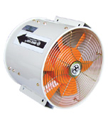 |  | 1/220/50 | 1.4 | 280 | 5,272 | 23 | 1,415
TIP-400DT  (Ø370 mm) |  |  | 3/220-380/60 | 1.5/0.9 | 400 | 6,060 | 30 | 1,650 | 66 | 15.5
 |  |  | 3/220-380/50 | 1.6/1.0 | 280 | 5,272 | 23 | 1,435
TIP-500D  (Ø470 mm) |  |  | 1/220/60 | 4.8 | 990 | 10,560 | 39 | 1,680 | 69 | 23
 |  |  | 1/220/50 | 3.3 | 690 | 8,970 | 29 | 1,465
TIP-500DT  (Ø470 mm) |  |  | 3/220-380/60 | 3.2/1.9 | 990 | 10,560 | 39 | 1,690 | 69 | 23
 |  |  | 3/220-380/50 | 3.2/1.8 | 690 | 8,970 | 29 | 1,455
TIP-600DS | 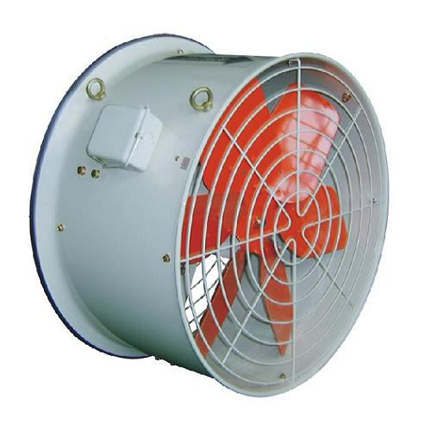 |  | 1/220/60 | 2 | 439 | 15,600 | 29 | 1,130 | 66 | 33
 |  |  | 1/220/50 | 1.5 | 315 | 13,200 | 21 | 985
TIP-600DT |  |  | 3/220-380/60 | 1.4/0.8 | 439 | 15,600 | 29 | 1,120 | 66 | 33
 |  |  | 3/220-380/50 | 1.0/0.6 | 315 | 13,200 | 21 | 965
 |  |  | Kích thước cánh quạt (mm): Ø600 mm
Quạt thổi áp lực cao (High-pressure blowers)
TBS-230  (Ø20.5 cm) |  |  | 1/220/60 | 1.9 | 330 | 660 | 120 | 3,440 | 83 | 12
 | 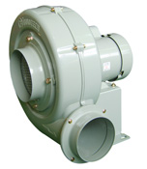 |  | 1/220/50 | 1.4 | 220 | 570 | 90 | 2,970
TBT-230  Ø20.5 cm) |  |  | 3/220-380/60 | 1.5/0.9 | 340 | 660 | 120 | 3,300 | 83 | 12
 |  |  | 3/220-380/50 | 1.6/1.0 | 260 | 570 | 90 | 2,850
TBS-270  Ø24.5 cm) |  |  | 1/220/60 | 4.8 | 680 | 1,200 | 170 | 3,430 | 80 | 15
 |  |  | 1/220/50 | 3.3 | 500 | 1,080 | 130 | 2,960
TBT-270  Ø24.5 cm) |  |  | 3/220-380/60 | 3.2/1.9 | 670 | 1,200 | 170 | 3,430 | 80 | 15
 |  |  | 3/220-380/50 | 3.2/1.8 | 470 | 1,080 | 130 | 2,960
TBS-230S  (Ø20.5 cm) |  |  | 1/220/60 | 1.9 | 330 | 660 | 120 | 3,440 | 83 | 12.5
 | 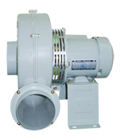 |  | 1/220/50 | 1.4 | 220 | 570 | 90 | 2,970
TBT-230S  Ø20.5 cm) |  |  | 3/220-380/60 | 1.5/0.9 | 340 | 660 | 120 | 3,300 | 83 | 12.5
 |  |  | 3/220-380/50 | 1.6/1.0 | 260 | 570 | 90 | 2,850
TBS-270S  Ø24.5 cm) |  |  | 1/220/60 | 4.8 | 680 | 1,200 | 170 | 3,430 | 80 | 15.5
 |  |  | 1/220/50 | 3.3 | 500 | 1,080 | 130 | 2,960
TBT-270S  Ø24.5 cm) |  |  | 3/220-380/60 | 3.2/1.9 | 670 | 1,200 | 170 | 3,430 | 80 | 15.5
 |  |  | 3/220-380/50 | 3.2/1.8 | 470 | 1,080 | 130 | 2,960
TBS-300 | 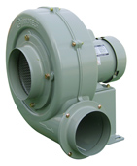 |  | 1/220/60 | 4.8 | 840 | 1,380 | 190 | 3,350 | 76 | 18.5
 |  |  | 1/220/50 | 3.3 | 570 | 1,200 | 145 | 2,890
TBT-300 |  |  | 3/220-380/60 | 3.2/1.9 | 850 | 1,380 | 190 | 3,360 | 76 | 18.5
 |  |  | 3/220-380/50 | 3.2/1.8 | 570 | 1,200 | 145 | 2,890
 |  |  | Kích thước cánh quạt (mm): Ø275 mm
TBS-300S | 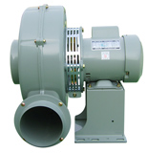 |  | 1/220/60 | 4.8 | 840 | 1,380 | 190 | 3,350 | 76 | 19
 |  |  | 1/220/50 | 3.3 | 570 | 1,200 | 145 | 2,890
TBT-300S |  |  | 3/220-380/60 | 3.2/1.9 | 850 | 1,380 | 190 | 3,360 | 76 | 19
 |  |  | 3/220-380/50 | 3.2/1.8 | 570 | 1,200 | 145 | 2,890
 |  |  | Kích thước cánh quạt (mm): Ø275 mm
TBS-301  (Ø275 mm) |  |  | 1/220/60 | 4.4 | 1,010 | 1,620 | 206 | 3,430 | 85 | 19
 | 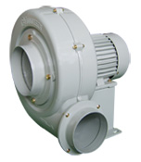 |  | 1/220/50 | 3.3 | 675 | 1,380 | 155 | 2,960
TBT-301  (Ø275 mm) |  |  | 3/220-380/60 | 3.0/1.8 | 1,030 | 1,620 | 206 | 3,430 | 85 | 19
 |  |  | 3/220-380/50 | 1.6/1.0 | 650 | 1,380 | 155 | 2,960
TBS-302  (Ø275 mm) |  |  | 1/220/60 | 4.8 | 1,050 | 1,710 | 215 | 3,450 | 86 | 20
 |  |  | 1/220/50 | 3.3 | 720 | 1,500 | 165 | 2,960
TBT-301  (Ø275 mm) |  |  | 3/220-380/60 | 4.0/2.3 | 1,050 | 1,710 | 215 | 3,450 | 86 | 20
 |  |  | 3/220-380/50 | 3.5/2.0 | 570 | 1,500 | 165 | 2,960
TBS-301S  (Ø275 mm) |  |  | 1/220/60 | 4.4 | 1,010 | 1,620 | 206 | 3,430 | 85 | 19
 | 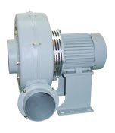 |  | 1/220/50 | 3.3 | 675 | 1,380 | 155 | 2,960
TBT-301S  (Ø275 mm) |  |  | 3/220-380/60 | 3.0/1.8 | 1,030 | 1,620 | 206 | 3,430 | 85 | 19
 |  |  | 3/220-380/50 | 1.6/1.0 | 650 | 1,380 | 155 | 2,960
TBS-302S  (Ø275 mm) |  |  | 1/220/60 | 4.8 | 1,050 | 1,710 | 215 | 3,450 | 86 | 20.5
 |  |  | 1/220/50 | 3.3 | 720 | 1,500 | 165 | 2,960
TBT-302S  (Ø275 mm) |  |  | 3/220-380/60 | 4.0/2.3 | 1,050 | 1,710 | 215 | 3,450 | 86 | 20.5
 |  |  | 3/220-380/50 | 3.5/2.0 | 570 | 1,500 | 165 | 2,960
TB-2B  (Ø185 mm) |  |  | 1/220/60 | 2.35 | 510 | 1,050 | 120 | 3,400 | 68 | 12
 | 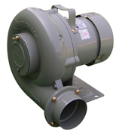 |  | 1/220/50 | 1.7 | 350 | 900 | 90 | 2,920
 |  |  | 3/220-380/60 | 1.62/0.9 | 510 | 1,050 | 120 | 3,350
 |  |  | 3/220-380/50 | 1.2/0.7 | 360 | 900 | 90 | 2,920
TB-4B  (Ø150 mm) |  |  | 1/220/60 | 1 | 210 | 426 | 75 | 3,400 | 67 | 7.5
 |  |  | 1/220/50 | 0.8 | 180 | 360 | 50 | 2,900
 |  |  | 3/220-380/60 | 0.75/0.42 | 230 | 426 | 75 | 3,400 | 86 | 20.5
 |  |  | 3/220-380/50 | 0.9/0.5 | 210 | 360 | 50 | 2,900
TB-2S  (Ø185 mm) |  |  | 1/220/60 | 2.35 | 510 | 1,050 | 120 | 3,400 | 68 | 12.5
 | 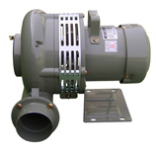 |  | 1/220/50 | 1.7 | 350 | 900 | 90 | 2,920
 |  |  | 3/220-380/60 | 1.62/0.9 | 510 | 1,050 | 120 | 3,350
 |  |  | 3/220-380/50 | 1.2/0.7 | 360 | 900 | 90 | 2,920
TB-4S  (Ø150 mm) |  |  | 1/220/60 | 1 | 210 | 426 | 75 | 3,400 | 67 | 8
 |  |  | 1/220/50 | 0.8 | 180 | 360 | 50 | 2,900
 |  |  | 3/220-380/60 | 0.75/0.42 | 230 | 426 | 75 | 3,400 | 86 | 20.5
 |  |  | 3/220-380/50 | 0.9/0.5 | 210 | 360 | 50 | 2,900
Sò thổi nhỏ (Small blowers)
TB-75 | 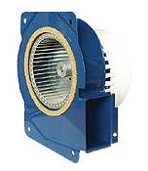 |  | 1/220/60 | 0.21 | 29 | 84 | 16 | 2,350 | 35 | 0.9
 |  |  | 1/220/50 | 0.2 | 23 | 78 | 14 | 2,245
 |  |  | Kích thước cánh quạt (mm): Ø85 x 70
TB-95 | 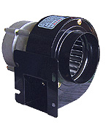 |  | 1/220/60 | 0.19 | 40 | 162 | 22 | 3,140 | 39 | 1.3
 |  |  | 1/220/50 | 0.18 | 32 | 128 | 18 | 2,730
 |  |  | Kích thước cánh quạt (mm): Ø88 x 40
TB-105 | 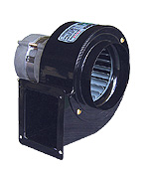 |  | 1/220/60 | 0.31 | 60 | 300 | 37 | 3,070 | 42 | 2.1
 |  |  | 1/220/50 | 0.26 | 48 | 240 | 32 | 2,730
 |  |  | Kích thước cánh quạt (mm): Ø105 x 50
TB-105F | 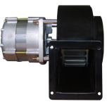 |  | 1/220/60 | 0.31 | 60 | 300 | 37 | 3,070 | 42 | 2.1
 |  |  | 1/220/50 | 0.26 | 48 | 270 | 32 | 2,730
 |  |  | Kích thước cánh quạt (mm): Ø105 x 50
TB-118 | 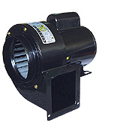 |  | 1/220/60 | 0.49 | 100 | 360 | 43 | 3,380 | 58 | 3.3
 |  |  | 1/220/50 | 0.48 | 91 | 324 | 30 | 2,910
 |  |  | Kích thước cánh quạt (mm): Ø115 x 50
TB-95-1 | 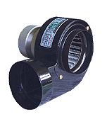 |  | 1/220/60 | 0.19 | 40 | 162 | 22 | 3,450 | 39 | 1.3
 |  |  | 1/220/50 | 0.18 | 32 | 128 | 18 | 2,960
TB-115 |  |  | 1/220/60 | 0.31 | 60 | 300 | 37 | 3,450 | 42 | 2.1
 |  |  | 1/220/50 | 0.26 | 48 | 240 | 32 | 2,960
 |  |  | Kích thước cánh quạt (mm): TB-95-1: Ø88 x 40; TB-115: Ø105 x 50
TB-118-1 | 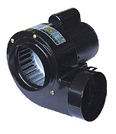 |  | 1/220/60 | 0.49 | 100 | 360 | 43 | 3,380 | 58 | 3.3
 |  |  | 1/220/50 | 0.48 | 91 | 324 | 30 | 2,910
 |  |  | Kích thước cánh quạt (mm): Ø115 x 50
TB-150  Ø118x60 |  |  | 1/220/60 | 0.9 | 209 | 480 | 49 | 3,470 | 62 | 6.4
 | 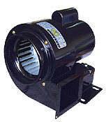 |  | 1/220/50 | 0.84 | 167 | 406 | 37 | 2,895
TB-150(3∮)  Ø118x60 |  |  | 3/220-380/60 | 0.85/0.75 | 209 | 480 | 49 | 3,410 | 62 | 6.4
 |  |  | 1/220/50 | 0.8/0.6 | 152 | 406 | 37 | 2,900
TB-200  Ø148x80 |  |  | 3/220-380/60 | 2.3 | 485 | 960 | 79 | 3,275 | 64 | 9
 |  |  | 1/220/50 | 1.8 | 367 | 844 | 62 | 2,865
TB-200(3∮)  Ø148x80 |  |  | 3/220-380/60 | 1.6/0.9 | 485 | 960 | 79 | 3,320 | 64 | 9
 |  |  | 1/220/50 | 1.7/1.0 | 386 | 844 | 62 | 2,895
TB-105S | 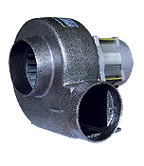 |  | 1/220/60 | 0.28 | 60 | 330 | 40 | 3,170 | 58 | 2.4
 |  |  | 1/220/50 | 0.26 | 52 | 287 | 30 | 2,765
TB-118S |  |  | 1/220/60 | 0.79 | 160 | 540 | 46 | 3,150 | 60 | 6.6
 |  |  | 1/220/50 | 0.73 | 139 | 470 | 30 | 2,760
 |  |  | Kích thước cánh quạt (mm): TB-105S: Ø105 x 60; TB-118S: Ø118 x 60
TB-105S-1 | 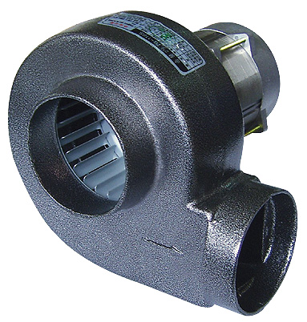 |  | 1/220/60 | 0.28 | 60 | 330 | 40 | 3,170 | 58 | 2.3
 |  |  | 1/220/50 | 0.26 | 52 | 287 | 30 | 2,765
TB-118S-1 |  |  | 1/220/60 | 0.79 | 160 | 540 | 46 | 3,150 | 60 | 6.5
 |  |  | 1/220/50 | 0.73 | 139 | 470 | 30 | 2,760
 |  |  | Kích thước cánh quạt (mm): TB-105S-1: Ø105 x 60; TB-118S-1: Ø118 x 60
TB-12B | 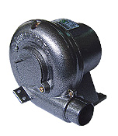 |  | 1/220/60 | 0.36 | 60 | 72 | 30 | 3,440 | 45 | 2.3
 |  |  | 1/220/50 | 0.27 | 60 | 72 | 30 | 2,890
TB-8B |  |  | 1/220/60 | 0.72 | 131 | 198 | 66 | 3,440 | 60 | 3.5
 |  |  | 1/220/50 | 0.51 | 131 | 198 | 66 | 2,830
 |  |  | Kích thước cánh quạt (mm): TB-12B: Ø148 x 28; TB-8B: Ø148 x 21
TB-6B | 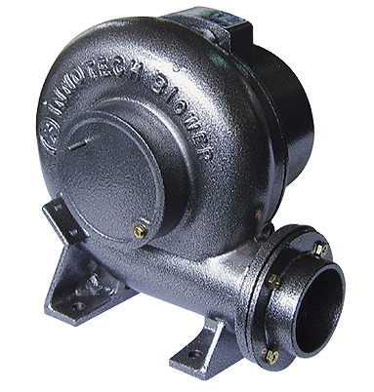 |  | 1/220/60 | 0.8 | 160 | 250 | 72 | 3,365 | 62 | 4.7
 |  |  | 1/220/50 | 0.68 | 125 | 232 | 66 | 2,890
 |  |  | Kích thước cánh quạt (mm): Ø140 x 50
TB-140DS | 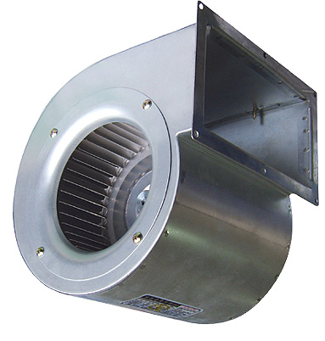 |  | 1/220/60 | 0.56 | 125 | 720 | 17 | 1,540 | 62 | 3
 |  |  | 1/220/50 | 0.43 | 83 | 675 | 14 | 1,230
 |  |  | Kích thước cánh quạt (mm): Ø140 x 50
(In line duct fans)
TJF-15B | 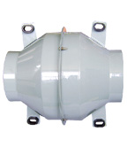 |  | 1/220/60 | 0.54 | 117 | 600 | 42 | 2,950 | 67 | 3.7
 |  |  | 1/220/50 | 0.45 | 95 | 516 | 32 | 2,640
 |  |  | Kích thước cánh quạt (mm): Ø85 x 70
TJF-20B | 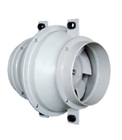 |  | 1/220/60 | 0.36 | 57 | 840 | 20 | 1,615 | 54 | 4.5
 |  |  | 1/220/50 | 0.31 | 55 | 720 | 15 | 1,420
TJF-25B |  |  | 1/220/60 | 0.43 | 91 | 1,440 | 30 | 1,625 | 58 | 6.8
 |  |  | 1/220/50 | 0.38 | 73 | 1,220 | 23 | 1,420
TJF-30B |  |  | 1/220/60 | 2.12 | 240 | 2,520 | 40 | 1,660 | 62 | 10.8
 |  |  | 1/220/50 | 0.87 | 170 | 2,140 | 30 | 1,425
TJF-200B | 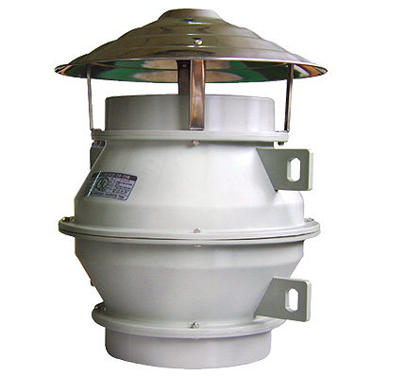 |  | 1/220/60 | 0.36 | 57 | 840 | 20 | 1,615 | 54 | 5.5
 |  |  | 1/220/50 | 0.31 | 55 | 720 | 15 | 1,420
TJF-250B |  |  | 1/220/60 | 0.43 | 91 | 1,440 | 30 | 1,625 | 58 | 8.3
 |  |  | 1/220/50 | 0.38 | 73 | 1,220 | 23 | 1,420
TJF-300B |  |  | 1/220/60 | 2.12 | 240 | 2,520 | 40 | 1,660 | 62 | 12
 |  |  | 1/220/50 | 0.87 | 170 | 2,140 | 30 | 1,425

BẢNG THÔNG TIN QUẠT WINDY FAN
Sản Phẩm |  |  | Thông số kỹ thuật
Model | Hình ảnh |  | Power  (∮/V/Hz) | I  (A) | D hút  (cm) | P vào  (W) | T. độ  (Rpm) | P ra  (kW) | Q  (m3/ph) | Áp lực  (Pa) | m  (Kg)
Quạt tròn lưu thông không khí (Circulating Ventilator)
DCF-400 | 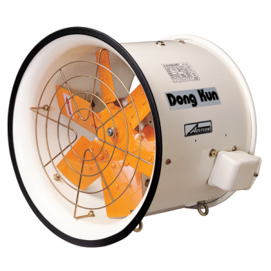 |  | 1/220/50 | 0.8 | 37 | 125 | 1,460 | 0.30 | 76 | 215 | 24
DCF-400 |  |  | 1/220/60 | 0.79 | 37 | 160 | 1,730 | 0.30 | 90 | 295 | 24
DCF-400 |  |  | 3/220-380/50 | 1.4/0.8 | 37 | 170 | 1,465 | 0.30 | 76 | 215 | 24
DCF-400 |  |  | 3/220-380/60 | 1.05/0.6 | 37 | 175 | 1,735 | 0.30 | 90 | 295 | 24
DCF-500 |  |  | 1/220/50 | 1.15 | 50 | 360 | 1,420 | 0.40 | 115 | 205 | 29
DCF-500 |  |  | 1/220/60 | 1.35 | 50 | 565 | 1,700 | 0.40 | 135 | 295 | 29
DCF-500 |  |  | 3/220-380/50 | 1.30/0.75 | 50 | 355 | 1,430 | 0.40 | 115 | 205 | 29
DCF-500 |  |  | 3/220-380/60 | 1.30/0.75 | 50 | 435 | 1,700 | 0.40 | 135 | 295 | 29
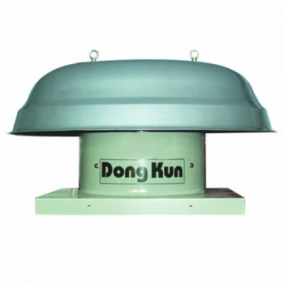  DCF-600 |  |  | 1/220/50 | 1.65 | 60 | 290 | 975 | 0.60 | 210 | 195 | 33
 |  |  | 1/220/60 | 1.7 | 60 | 375 | 1,175 | 0.60 | 250 | 275 | 33
 |  |  | 3/220-380/50 | 2.6/1.5 | 60 | 295 | 980 | 0.30 | 210 | 195 | 33
 |  |  | 3/220-380/60 | 2.05/1.2 | 60 | 330 | 1,170 | 0.30 | 250 | 275 | 33
DCF-800 |  |  | 1/220/50 | 4.8 | 80 | 900 | 965 | 1.50 | 380 | 275 | 38
DCF-800 |  |  | 1/220/60 | 6.6 | 80 | 1,450 | 1,145 | 1.50 | 450 | 295 | 38
DCF-800 |  |  | 3/220-380/50 | 6.7/3.85 | 80 | 980 | 970 | 1.50 | 380 | 275 | 38
DCF-800 |  |  | 3/220-380/60 | 5.8/3.35 | 80 | 1,350 | 1,150 | 1.50 | 450 | 295 | 38
DVR-400
DVR-500
DVR-600

SẢN PHẨM | TÊN SẢN PHẨM |  | SẢN PHẢM | TÊN SẢN PHẨM | SỐ TIỀN
QUẠT CAO ÁP  ( TIÊU CHUẨN)  고압송풍기  (일반용) | TBS-230 | 4,718,314 | ĐA TẦNG TURBO  (TIÊU CHUẨN)  다단 브로아  (75Φ)  (일반형) | ITB-401S | 11,819,808
QUẠT CAO ÁP  ( TIÊU CHUẨN)  고압송풍기  (일반용) | TBT-230 | 4,718,314 | ĐA TẦNG TURBO  (TIÊU CHUẨN)  다단 브로아  (75Φ)  (일반형) | ITB-401T | 10,906,896
QUẠT CAO ÁP  ( TIÊU CHUẨN)  고압송풍기  (일반용) | TBS-270 | 6,246,240 | ĐA TẦNG TURBO  (TIÊU CHUẨN)  다단 브로아  (75Φ)  (일반형) | ITB-402S | 15,903,888
QUẠT CAO ÁP  ( TIÊU CHUẨN)  고압송풍기  (일반용) | TBT-270 | 6,246,240 | ĐA TẦNG TURBO  (TIÊU CHUẨN)  다단 브로아  (75Φ)  (일반형) | ITB-402T | 14,990,976
QUẠT CAO ÁP  ( TIÊU CHUẨN)  고압송풍기  (일반용) | TBS-300 | 8,024,016 | ĐA TẦNG TURBO  (TIÊU CHUẨN)  다단 브로아  (75Φ)  (일반형) | ITB-403T | 19,939,920
QUẠT CAO ÁP  ( TIÊU CHUẨN)  고압송풍기  (일반용) | TBT-300 | 8,024,016 | ĐA TẦNG TURBO  (TIÊU CHUẨN)  다단 브로아  (75Φ)  (일반형) | ITB-404T | 23,639,616
QUẠT CAO ÁP  ( TIÊU CHUẨN)  고압송풍기  (일반용) | TBS-301 | 10,666,656 | ĐA TẦNG TURBO  (TIÊU CHUẨN)  다단 브로아  (75Φ)  (일반형) | ITB-405T | 28,684,656
QUẠT CAO ÁP  ( TIÊU CHUẨN)  고압송풍기  (일반용) | TBT-301 | 10,330,320 | ĐA TẦNG TURBO  (TIÊU CHUẨN)  다단 브로아  (75Φ)  (일반형) | ITB-406T | 31,471,440
QUẠT CAO ÁP  ( TIÊU CHUẨN)  고압송풍기  (일반용) | TBS-302 | 14,030,016 | BLOWER  (75Φ)  (고온용)  NHIỆT ĐỘ CAO | ITB-S401S고온용CF | 13,165,152
QUẠT CAO ÁP  ( TIÊU CHUẨN)  고압송풍기  (일반용) | TBT-302 | 13,789,776 | BLOWER  (75Φ)  (고온용)  NHIỆT ĐỘ CAO | ITB-S401T고온용CF | 12,252,240
QUẠT CAO ÁP  ( NHIỆT ĐỘ CAO)  고압송풍기  (고온용) | TBS-230S | 6,150,144 | BLOWER  (75Φ)  (고온용)  NHIỆT ĐỘ CAO | ITB-S402S고온용CF | 17,297,280
QUẠT CAO ÁP  ( NHIỆT ĐỘ CAO)  고압송풍기  (고온용) | TBT-230S | 6,150,144 | BLOWER  (75Φ)  (고온용)  NHIỆT ĐỘ CAO | ITB-S402T고온용CF | 16,240,224
QUẠT CAO ÁP  ( NHIỆT ĐỘ CAO)  고압송풍기  (고온용) | TBS-270S | 8,024,016 | BLOWER  (75Φ)  (고온용)  NHIỆT ĐỘ CAO | ITB-S403T고온용AF | -
QUẠT CAO ÁP  ( NHIỆT ĐỘ CAO)  고압송풍기  (고온용) | TBT-270S | 8,024,016 | BLOWER  (75Φ)  (고온용)  NHIỆT ĐỘ CAO | ITB-S404T고온용AF | -
QUẠT CAO ÁP  ( NHIỆT ĐỘ CAO)  고압송풍기  (고온용) | TBS-300S | 8,936,928 | BLOWER  (75Φ)  (고온용)  NHIỆT ĐỘ CAO | ITB-S405T고온용AF | -
QUẠT CAO ÁP  ( NHIỆT ĐỘ CAO)  고압송풍기  (고온용) | TBT-300S | 8,936,928 | BLOWER  (75Φ)  (고온용)  NHIỆT ĐỘ CAO | ITB-S406T고온용AF | -
QUẠT CAO ÁP  ( NHIỆT ĐỘ CAO)  고압송풍기  (고온용) | TBS-301S | 12,924,912 | BLOWRE ĐA TẦNG  (125Φ)  (일반용) | ITB-411(1∮) | 15,951,936
QUẠT CAO ÁP  ( NHIỆT ĐỘ CAO)  고압송풍기  (고온용) | TBT-301S | 12,732,720 | BLOWRE ĐA TẦNG  (125Φ)  (일반용) | ITB-411 (3∮) | 14,942,928
QUẠT CAO ÁP  ( NHIỆT ĐỘ CAO)  고압송풍기  (고온용) | TBS-302S | 15,711,696 | BLOWRE ĐA TẦNG  (125Φ)  (일반용) | ITB-412 (3∮) | 19,555,536
QUẠT CAO ÁP  ( NHIỆT ĐỘ CAO)  고압송풍기  (고온용) | TBT-302S | 15,375,360 | BLOWRE ĐA TẦNG  (125Φ)  (일반용) | ITB-413 (3∮) | 23,303,280
QUẠT HÚT BỤI | IDT-100S | - | BLOWRE ĐA TẦNG  (125Φ)  (일반용) | ITB-414 (3∮) | 28,828,800
QUẠT HÚT BỤI | IDT-100T | - | 다단 브로아  (125Φ)  (고온용)  NHIỆT ĐỘ CAO | ITB-411S(1∮)고온용CF | 17,441,424
QUẠT HÚT BỤI | IDT-200S | - | 다단 브로아  (125Φ)  (고온용)  NHIỆT ĐỘ CAO | ITB-411S(3∮)고온용CF | 16,576,560
QUẠT HÚT BỤI | IDT-200T | - | 다단 브로아  (125Φ)  (고온용)  NHIỆT ĐỘ CAO | ITB-412S(3∮)고온용AF | -
QUẠT HÚT BỤI | IDT-300S | - | 다단 브로아  (125Φ)  (고온용)  NHIỆT ĐỘ CAO | ITB-413S(3∮)고온용AF | -
QUẠT HÚT BỤI | IDT-300T | - | 다단 브로아  (125Φ)  (고온용)  NHIỆT ĐỘ CAO | ITB-414S(3∮)고온용AF | -
QUẠT HÚT BỤI | IDT-500T | - | 다단 브로아  (125Φ)  (고온용)  NHIỆT ĐỘ CAO |  | -
QUẠT HÚT BỤI | IDT-750T | - | 다단 브로아  (125Φ)  (고온용)  NHIỆT ĐỘ CAO |  | -
QUẠT HÚT BỤI | IDT-1000T | - | 다단 브로아  (125Φ)  (고온용)  NHIỆT ĐỘ CAO |  | -

SẢN PHẨM | TÊN SẢN PHẨM |  | SẢN PHẨM | TÊN SẢN PHẨM | SỐ TIỀN
QUẠT SÒ CAO ÁP LOẠI NHỎ | TB-70 | 619,819 | QUẠT TORBO | TBS-3235S(1HP) | 9,465,456
QUẠT SÒ CAO ÁP LOẠI NHỎ | TB-70-1 | 619,819 | QUẠT TORBO | TBS-3245S(2HP) | 10,714,704
QUẠT SÒ CAO ÁP LOẠI NHỎ | TB-75 | 619,819 | QUẠT TORBO | TBS-3735S(3HP) | 12,732,720
QUẠT SÒ CAO ÁP LOẠI NHỎ | TB-95 | 845,645 | QUẠT TORBO | TBS-3235T(1HP) | 8,696,688
QUẠT SÒ CAO ÁP LOẠI NHỎ | TB-95N | 936,936 | QUẠT TORBO | TBS-3245T(2HP) | 9,849,840
QUẠT SÒ CAO ÁP LOẠI NHỎ | TB-105 | 1,013,813 | QUẠT TORBO | TBS-3735T(3HP) | 11,579,568
QUẠT SÒ CAO ÁP LOẠI NHỎ | TB-118 | 1,672,070 | QUẠT TORBO | TBS-3765T(5HP) | 13,309,296
QUẠT SÒ CAO ÁP LOẠI NHỎ | TB-150(1∮) | 2,253,451 | QUẠT TORBO | TBS-S3235S(1HP) | 13,117,104
QUẠT SÒ CAO ÁP LOẠI NHỎ | TB-150(3∮) | 2,253,451 | QUẠT TORBO | TBS-S3245S(2HP) | 14,318,304
QUẠT SÒ CAO ÁP LOẠI NHỎ | TB-200(1∮) | 2,762,760 | QUẠT TORBO | TBS-S3735S(3HP) | 16,336,320
QUẠT SÒ CAO ÁP LOẠI NHỎ | TB-200(3∮) | 2,762,760 | QUẠT TORBO | TBS-S3235T(1HP) | 12,300,288
QUẠT SÒ CAO ÁP LOẠI NHỎ | TB-95-1 | 874,474 | QUẠT TORBO | TBS-S3245T(2HP) | 13,453,440
QUẠT SÒ CAO ÁP LOẠI NHỎ | TB-115 | 1,066,666 | QUẠT TORBO | TBS-S3735T(3HP) | 15,183,168
QUẠT SÒ CAO ÁP LOẠI NHỎ | TB-118-1 | 1,748,947 | QUẠT TORBO | TBS-S3765T(5HP) | 16,960,944
QUẠT SÒ CAO ÁP LOẠI NHỎ | TB-95F | 1,013,813 | QUẠT TORBO  THÉP KHÔNG RỈ | TBP-3235S(1HP) SUS | 21,333,312
QUẠT SÒ CAO ÁP LOẠI NHỎ | TB-105F | 1,297,296 | QUẠT TORBO  THÉP KHÔNG RỈ | TBP-3245S(2HP) SUS | 23,879,856
QUẠT SÒ CAO ÁP LOẠI NHỎ | TB-118F | 2,051,650 | QUẠT TORBO  THÉP KHÔNG RỈ | TBP-3735S(3HP) SUS | 27,579,552
QUẠT SÒ CAO ÁP LOẠI NHỎ | TB-150F(1∮) | 2,628,226 | QUẠT TORBO  THÉP KHÔNG RỈ | TBP-3235T(1HP) SUS | 21,093,072
QUẠT SÒ CAO ÁP LOẠI NHỎ | TB-150F(3∮) | 2,628,226 | QUẠT TORBO  THÉP KHÔNG RỈ | TBP-3245T(2HP) SUS | 23,159,136
QUẠT SÒ CAO ÁP LOẠI NHỎ | TB-200F(1∮) | 3,171,168 | QUẠT TORBO  THÉP KHÔNG RỈ | TBP-3735T(3HP) SUS | 26,810,784
QUẠT SÒ CAO ÁP LOẠI NHỎ | TB-200F(3∮) | 3,171,168 | QUẠT TORBO  THÉP KHÔNG RỈ | TBP-3765T(5HP) SUS | 30,510,480
QUẠT SÒ CAO ÁP LOẠI NHỎ | TB-95-1F | 1,047,446 | QUẠT TORBO  THÉP KHÔNG RỈ | TBP-S3235S(1HP) SUS | 24,984,960
QUẠT SÒ CAO ÁP LOẠI NHỎ | TB-115F | 1,326,125 | QUẠT TORBO  THÉP KHÔNG RỈ | TBP-S3245S(2HP) SUS | 27,579,552
QUẠT SÒ CAO ÁP LOẠI NHỎ | TB-118-1F | 2,200,598 | QUẠT TORBO  THÉP KHÔNG RỈ | TBP-S3735S(3HP) SUS | 31,231,200
QUẠT SÒ CAO ÁP LOẠI NHỎ | TB-150(100Φ) | 115,315 | QUẠT TORBO  THÉP KHÔNG RỈ | TBP-S3235T(1HP) SUS | 24,744,720
QUẠT SÒ CAO ÁP LOẠI NHỎ | TB-200(125Φ) | 129,730 | QUẠT TORBO  THÉP KHÔNG RỈ | TBP-S3245T(2HP) SUS | 26,810,784
QUẠT SÒ THÉP KHÔNG RỈ | TB-105(SS) | 2,272,670 | QUẠT TORBO  THÉP KHÔNG RỈ | TBP-S3735T(3HP) SUS | 30,510,480
QUẠT SÒ THÉP KHÔNG RỈ | TB-118(SS) | 3,286,483 | QUẠT TORBO  THÉP KHÔNG RỈ | TBP-S3765T(5HP) SUS | 34,210,176
QUẠT SÒ THÉP KHÔNG RỈ | TB-150(1∮)(SS) | 3,915,912 | QUẠT SÒ CO ÁP NHỎ | TB-12B | 1,292,491
QUẠT SÒ THÉP KHÔNG RỈ | TB-150(3∮)(SS) | 3,915,912 | QUẠT SÒ CO ÁP NHỎ | TB-8B | 1,724,923
QUẠT SÒ THÉP KHÔNG RỈ | TB-200(1∮)(SS) | 4,785,581 | QUẠT SÒ CO ÁP NHỎ | TB-6B | 2,200,598
QUẠT SÒ THÉP KHÔNG RỈ | TB-200(3∮)(SS) | 4,785,581 | QUẠT SÒ CO ÁP NHỎ | TB-4B(1∮) | 3,022,219
QUẠT SÒ THÉP KHÔNG RỈ | TB-115(SS) | 2,339,938 | QUẠT SÒ CO ÁP NHỎ | TB-4B(3∮) | 3,022,219
QUẠT SÒ THÉP KHÔNG RỈ | TB-118-1(SS) | 3,353,750 | QUẠT SÒ CO ÁP NHỎ | TB-2B(1∮) | 3,819,816
QUẠT SÒ THÉP KHÔNG RỈ | TB-105F(SS) | 2,479,277 | QUẠT SÒ CO ÁP NHỎ | TB-2B(3∮) | 3,819,816
QUẠT SÒ THÉP KHÔNG RỈ | TB-118F(SS) | 3,459,456 | QUẠT SÒ CO ÁP NHỎ | TB-4S(1∮) | 3,781,378
QUẠT SÒ THÉP KHÔNG RỈ | TB-150F(1∮)(SS) | 4,194,590 | QUẠT SÒ CO ÁP NHỎ | TB-4S(3∮) | 3,781,378
QUẠT SÒ THÉP KHÔNG RỈ | TB-150F(3∮)(SS) | 4,194,590 | QUẠT SÒ CO ÁP NHỎ | TB-2S(1∮) | 4,497,293
QUẠT SÒ THÉP KHÔNG RỈ | TB-200F(1∮)(SS) | 5,045,040 | QUẠT SÒ CO ÁP NHỎ | TB-2S(3∮) | 4,497,293
QUẠT SÒ THÉP KHÔNG RỈ | TB-200F(3∮)(SS) | 5,045,040 | QUẠT SÒ VỎ NHÔM | TB-105S/TBW-51 (신형) | 1,369,368
QUẠT SÒ THÉP KHÔNG RỈ | TB-115F(SS) | 2,551,349 | QUẠT SÒ VỎ NHÔM | TB-105S-1(신형) | 1,282,882
QUẠT SÒ THÉP KHÔNG RỈ | TB-118-1F(SS) | 3,598,795 | QUẠT SÒ VỎ NHÔM | TBW-101 (CW) | 2,412,010
QUẠT SÒ THÉP KHÔNG RỈ | TB-150(SS)(100Φ) | 490,090 | QUẠT SÒ VỎ NHÔM | TBW-103 (CW) | 2,412,010
QUẠT SÒ THÉP KHÔNG RỈ | TB-200(SS)(125Φ) | 557,357 | QUẠT SÒ VỎ NHÔM | TBW-101-1 (CW) | 2,301,499
(고온용) | TB-F105S | 1,542,341 | QUẠT SÒ VỎ NHÔM | TBW-103-1 (CW) | 2,301,499
(고온용) | TBW-101F (CW) | 2,628,226 | 지 하  주차장팬 | TIV-200D | 6,966,960
(고온용) | TBW-103F (CW) | 2,628,226 | 지 하  주차장팬 | TIV-250D | 7,399,392
모타ST(일반50) | TB105SM(신형) | 1,090,690 | QUẠT SÒ NHỎ THỔI LÒ | TB-105S (구형) | 1,258,858
모타ST(일반50) | TBW-101M-103M*45*12Ø | 1,527,926 | QUẠT SÒ NHỎ THỔI LÒ | TB-105S-1 (구형) | 1,258,858
모타ST(장축75) | TBW-101FM-103FM*75*12Ø | 1,657,656 | QUẠT SÒ NHỎ THỔI LÒ | TB-118S (구형) | 1,801,800
모타SUS(장축114) | TBW-101FM-103FM*114*12Ø | 2,094,893 | QUẠT SÒ NHỎ THỔI LÒ | TB-118S-1 (구형) | 1,801,800

SẢN PHẨM | TÊN SẢN PHẨM | SỐ TIỀN | SẢN PHẨM | TÊN SẢN PHẨM | SỐ TIỀN
QUẠT LY TÂM LOẠI THƯỜNG | TIS-140FS | 2,094,893 | QUẠT HƯỚNG TRỤC TRÒN LOẠI NHỎ | TIP-200S | 3,565,162
QUẠT LY TÂM LOẠI THƯỜNG | TIS-160FS | 2,517,715 | QUẠT HƯỚNG TRỤC TRÒN LOẠI NHỎ | TIP-250S | 4,016,813
QUẠT LY TÂM LOẠI THƯỜNG | TIS-190FS | 3,214,411 | QUẠT HƯỚNG TRỤC TRÒN LOẠI NHỎ | TIP-300S | 4,718,314
QUẠT LY TÂM LOẠI THƯỜNG | TIS-190FT | 3,214,411 | QUẠT HƯỚNG TRỤC TRÒN LOẠI NHỎ | TIP-350S | 6,582,576
QUẠT LY TÂM LOẠI THƯỜNG | TIS-250GS | 5,429,424 | QUẠT HƯỚNG TRỤC TRÒN LOẠI NHỎ | TIP-400S | 7,927,920
QUẠT LY TÂM LOẠI THƯỜNG | TIS-250GT | 5,429,424 | QUẠT HƯỚNG TRỤC TRÒN LOẠI NHỎ | TIP-400T | 7,927,920
QUẠT LY TÂM LOẠI THƯỜNG | TIS-280FS | 6,438,432 | QUẠT HƯỚNG TRỤC TRÒN LOẠI NHỎ | TIP-500S | 9,801,792
QUẠT LY TÂM LOẠI THƯỜNG | TIS-280FT | 6,294,288 | QUẠT HƯỚNG TRỤC TRÒN LOẠI NHỎ | TIP-500T | 9,801,792
QUẠT LY TÂM LOẠI THƯỜNG | TIS-280GS | 6,438,432 | QUẠT HƯỚNG TRỤC TRÒN LOẠI LỚN | TIP-300S-1 | 5,477,472
QUẠT LY TÂM LOẠI THƯỜNG | TIS-280GT | 6,294,288 | QUẠT HƯỚNG TRỤC TRÒN LOẠI LỚN | TIP-400S-1 | 9,801,792
QUẠT LY TÂM LOẠI THƯỜNG | TIS-290FS | 7,879,872 | QUẠT HƯỚNG TRỤC TRÒN LOẠI LỚN | TIP-400T-1 | 9,801,792
QUẠT LY TÂM LOẠI THƯỜNG | TIS-290FT | 7,687,680 | QUẠT HƯỚNG TRỤC TRÒN LOẠI LỚN | TIP-500S-1 | 12,588,576
QUẠT LY TÂM LOẠI THƯỜNG | TIS-290GS | 6,630,624 | QUẠT HƯỚNG TRỤC TRÒN LOẠI LỚN | TIP-500T-1 | 12,588,576
2.5HP벨트 | TIS-B310FS(belt) | 19,219,200 | QUẠT HƯỚNG TRỤC TRÒN LOẠI LỚN | TIP-600S-1 | 17,489,472
2.5HP벨트 | TIS-B310FT(belt) | 19,219,200 | QUẠT HƯỚNG TRỤC TRÒN LOẠI LỚN | TIP-600T-1 | 17,393,376
QUẠT LY TÂM LOẠI LỚN  대 형  시로코팬 | TIS-310GS | 15,279,264 | QUẠT HƯỚNG TRỤC LOẠI CÔNG NGHIỆP | TIP-400D(4P) | 7,831,824
QUẠT LY TÂM LOẠI LỚN  대 형  시로코팬 | TIS-310GT | 14,846,832 | QUẠT HƯỚNG TRỤC LOẠI CÔNG NGHIỆP | TIP-400D(4P) | 7,831,824
QUẠT LY TÂM LOẠI LỚN  대 형  시로코팬 | TIS-370GS | 17,537,520 | QUẠT HƯỚNG TRỤC LOẠI CÔNG NGHIỆP | TIP-500DS | 9,081,072
QUẠT LY TÂM LOẠI LỚN  대 형  시로코팬 | TIS-370GT | 15,903,888 | QUẠT HƯỚNG TRỤC LOẠI CÔNG NGHIỆP | TIP-500DT | 9,081,072
QUẠT LY TÂM LOẠI LỚN  대 형  시로코팬 | TIS-390GT | 18,162,144 | QUẠT HƯỚNG TRỤC LOẠI CÔNG NGHIỆP | TIP-600DS(6P) | 11,147,136
QUẠT LY TÂM LOẠI LỚN  대 형  시로코팬 | TIS-390HT | 18,162,144 | QUẠT HƯỚNG TRỤC LOẠI CÔNG NGHIỆP | TIP-600DT(6P) | 11,147,136
QUẠT LY TÂM THÉP KHÔNG RỈ | TIS-S250GS(SUS) | 20,036,016 | QUẠT HƯỚNG TRỤC LOẠI CÔNG NGHIỆP | TIP-800DS(6P) | 13,981,968
QUẠT LY TÂM THÉP KHÔNG RỈ | TIS-S250GT(SUS) | 20,036,016 | QUẠT HƯỚNG TRỤC LOẠI CÔNG NGHIỆP | TIP-800DT(6P) | 13,981,968
QUẠT LY TÂM THÉP KHÔNG RỈ | TIS-S280FS(SUS) | 21,525,504 | QUẠT HƯỚNG TRỤC VUÔNG THÔNG GIÓ | TIH-200S | 1,047,446
QUẠT LY TÂM THÉP KHÔNG RỈ | TIS-S280FT(SUS) | 21,525,504 | QUẠT HƯỚNG TRỤC VUÔNG THÔNG GIÓ | TIH-250S | 1,133,933
양흡입팬 | TB-140DS | 1,292,491 | QUẠT HƯỚNG TRỤC VUÔNG THÔNG GIÓ | TIH-300S | 1,273,272
LY TÂM HỘP LỚN - NHỎ | ITC-230GS | 7,879,872 | QUẠT HƯỚNG TRỤC VUÔNG THÔNG GIÓ | TIH-350S | 1,624,022
LY TÂM HỘP LỚN - NHỎ | ITC-230GT | 7,783,776 | QUẠT HƯỚNG TRỤC VUÔNG THÔNG GIÓ | TIH-400S | 2,166,965
LY TÂM HỘP LỚN - NHỎ | ITC-250GS | 8,408,400 | QUẠT HƯỚNG TRỤC VUÔNG THÔNG GIÓ | TIH-400T | 2,234,232
LY TÂM HỘP LỚN - NHỎ | ITC-250GT | 8,360,352 | QUẠT HƯỚNG TRỤC VUÔNG THÔNG GIÓ | TIH-450S | 5,045,040
LY TÂM HỘP LỚN - NHỎ | ITC-300GS | 10,810,800 | QUẠT HƯỚNG TRỤC VUÔNG THÔNG GIÓ | TIH-450T | 5,045,040
LY TÂM HỘP LỚN - NHỎ | ITC-300GT | 10,714,704 | QUẠT HƯỚNG TRỤC VUÔNG THÔNG GIÓ | TIH-500S | 6,246,240
LY TÂM HỘP LỚN - NHỎ | ITC-350FS | 0 | QUẠT HƯỚNG TRỤC VUÔNG THÔNG GIÓ | TIH-500GS | 6,246,240
LY TÂM HỘP LOẠI LỚN | ITC-350FT | 0 | QUẠT HƯỚNG TRỤC VUÔNG THÔNG GIÓ | TIH-500T | 6,150,144
LY TÂM HỘP LOẠI LỚN | ITC-380HS | 21,093,072 | 회전조절기 | IH-15 (600/1) | 7,927,920
LY TÂM HỘP LOẠI LỚN | ITC-380HT | 17,105,088 | 셔 터 | 8"-300*300 | 432,432
LY TÂM HỘP LOẠI LỚN | ITC-400GT | 22,005,984 | 셔 터 | 10"-350*350 | 494,894
QUẠT  HƯỚNG TRỤC BẦU | TJF-15B | 2,094,893 | 셔 터 | 12"-400*400 | 557,357
QUẠT  HƯỚNG TRỤC BẦU | TJF-20B | 2,445,643 | 셔 터 | 14"-440*440 | 648,648
QUẠT  HƯỚNG TRỤC BẦU | TJF-25B | 3,320,117 | 셔 터 | 16"-490*490 | 773,573
QUẠT  HƯỚNG TRỤC BẦU | TJF-30B | 5,429,424 | 셔 터 | 20"-620*620 | 1,422,221
ĐƯỜNG ỐNG | TJF-200B | 3,147,144 | PLASTIC  QUẠT NHỰA | TWP-201GD | 715,915
ĐƯỜNG ỐNG | TJF-250B | 4,454,050 | PLASTIC  QUẠT NHỰA | TWP-201G | 715,915
ĐƯỜNG ỐNG | TJF-300B | 7,351,344 | PLASTIC  QUẠT NHỰA | TWP-251G | 768,768
QUẠT NHÀ VS | TWP-10C | 273,874 | PLASTIC  QUẠT NHỰA | TWP-301G | 1,085,885
QUẠT NHÀ VS | TWP-15C | 307,507 | PLASTIC  QUẠT NHỰA | INV-200G | 715,915
엘 보 | ELBOW-10C | 81,682 | PLASTIC  QUẠT NHỰA | INV-250G | 768,768
천정용팬 | TWP-150CG | 888,888 | 보급형팬  (일반형) | TWP-20C | 466,066
디프셔팬 | TWP-15P | 273,874 | 보급형팬  (일반형) | TWP-25C | 538,138
디프셔팬 | TWP-20P | 470,870 | 보급형팬  (일반형) | INV-20CD | 538,138

